Introduction to Power BI
1-2. Installation OF NECESSARY TOOLS and Adventure Works DWH
Power BI Desktop was downloaded and installed without any issues. SQL Server Management Studio (SSMS) was also installed, and the AdventureWorksDW2017.bak database was restored using the ‘Restore Database’ option in SSMS by selecting the .bak file as a Device source. The restore completed successfully on the first attempt.
3. Building a simple Power BI Report
3.1. Load Data
To connect Power BI to the local SQL Server, the server name in the format .\SQLEXPRESS (where the dot (.) is a shorthand for the local machine name, equivalent to localhost\SQLEXPRESS ) was entered in the SQL Server Database window and data Connection mode “Import” was chosen:
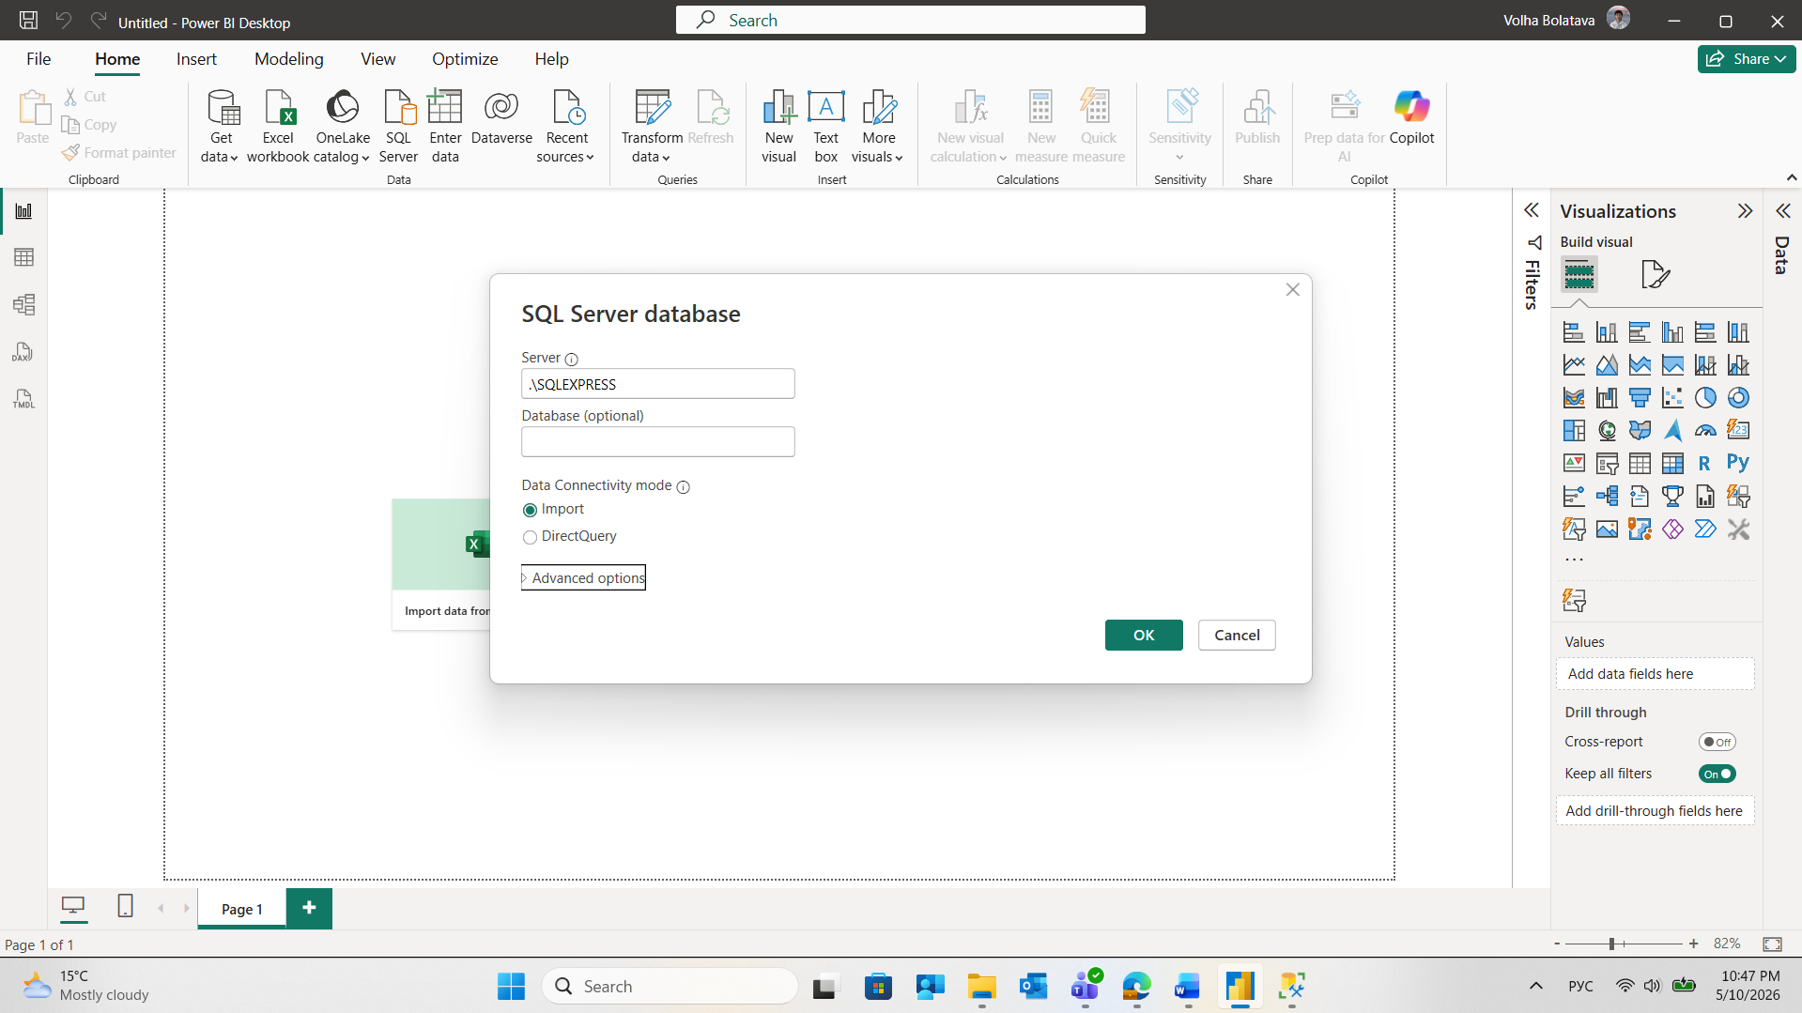
In the Navigator, the FactInternetSales table was selected and the ‘Select Related Tables’ button was used to automatically include all related dimension tables.
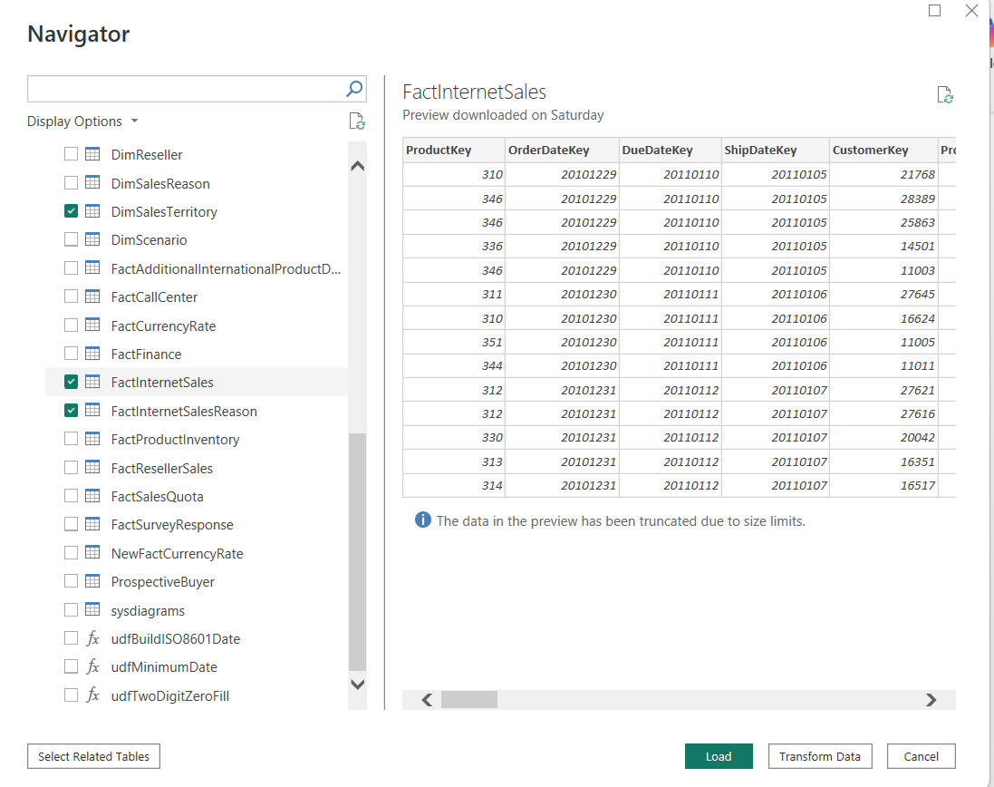
The process ran smoothly and all required tables appeared in Power Query Editor:
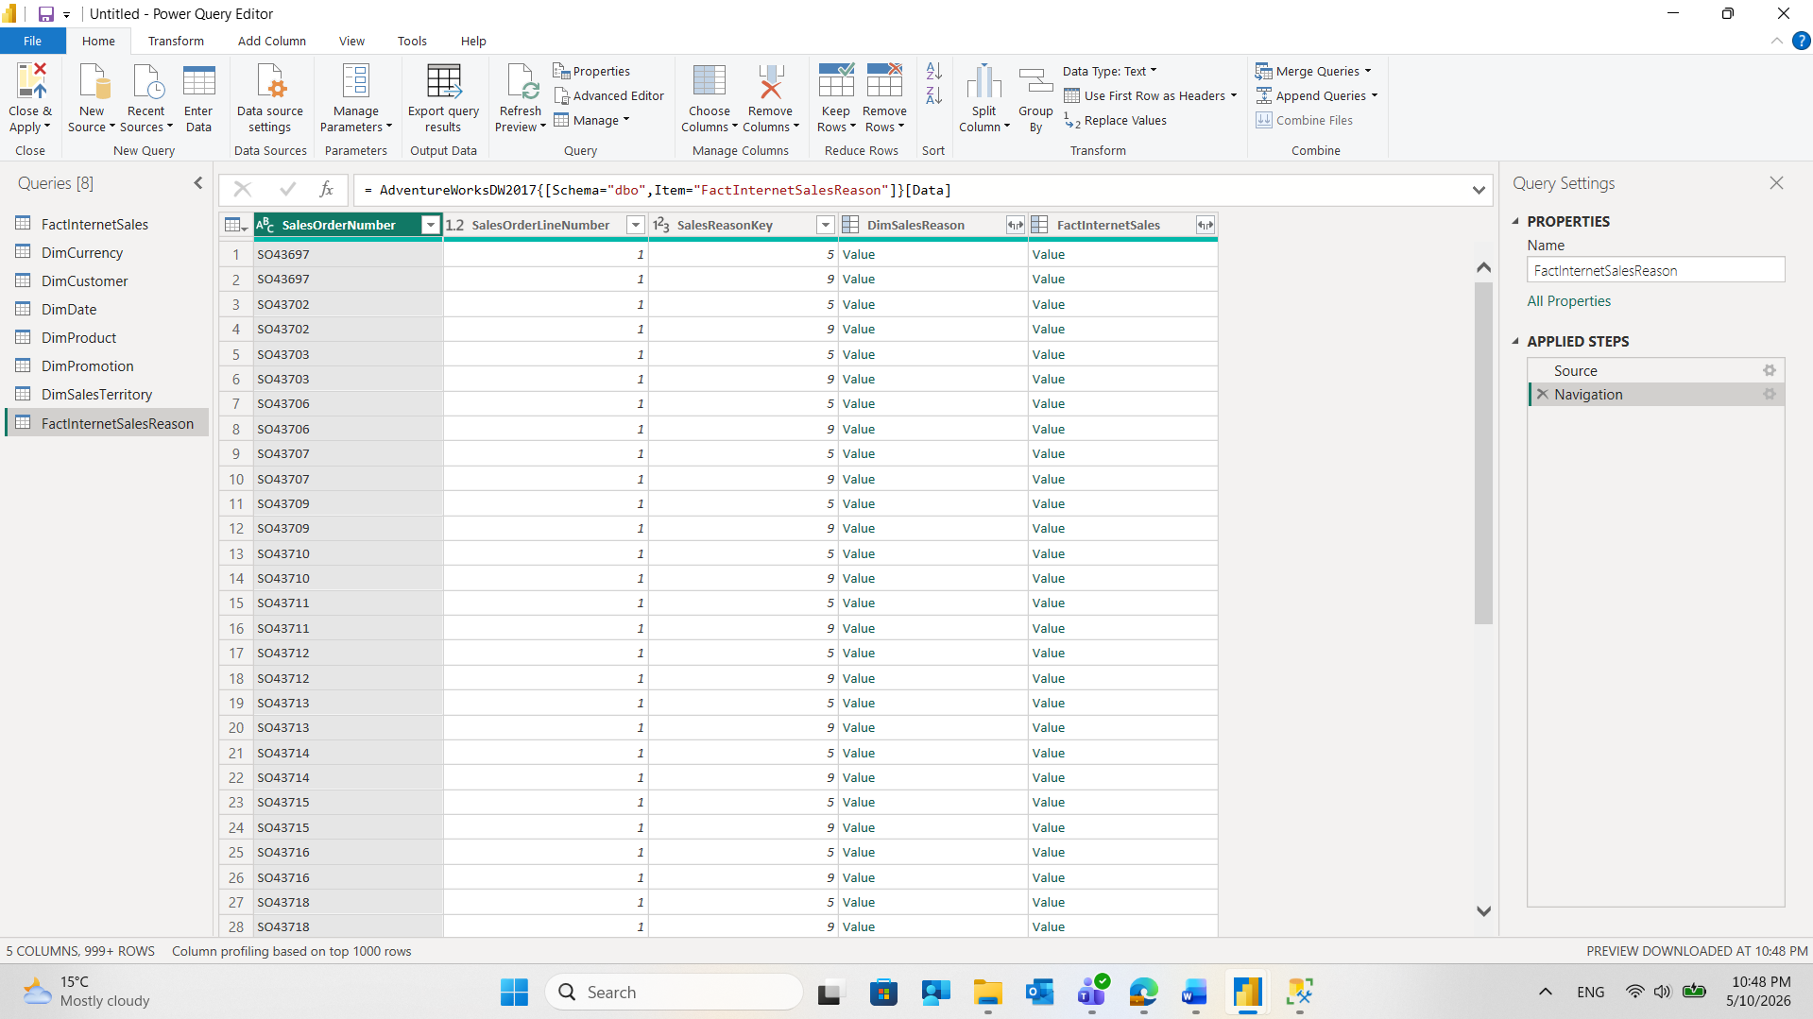
4.2 Basic Data Transformation
‘First Name’ and ‘Last Name’ columns were duplicated:
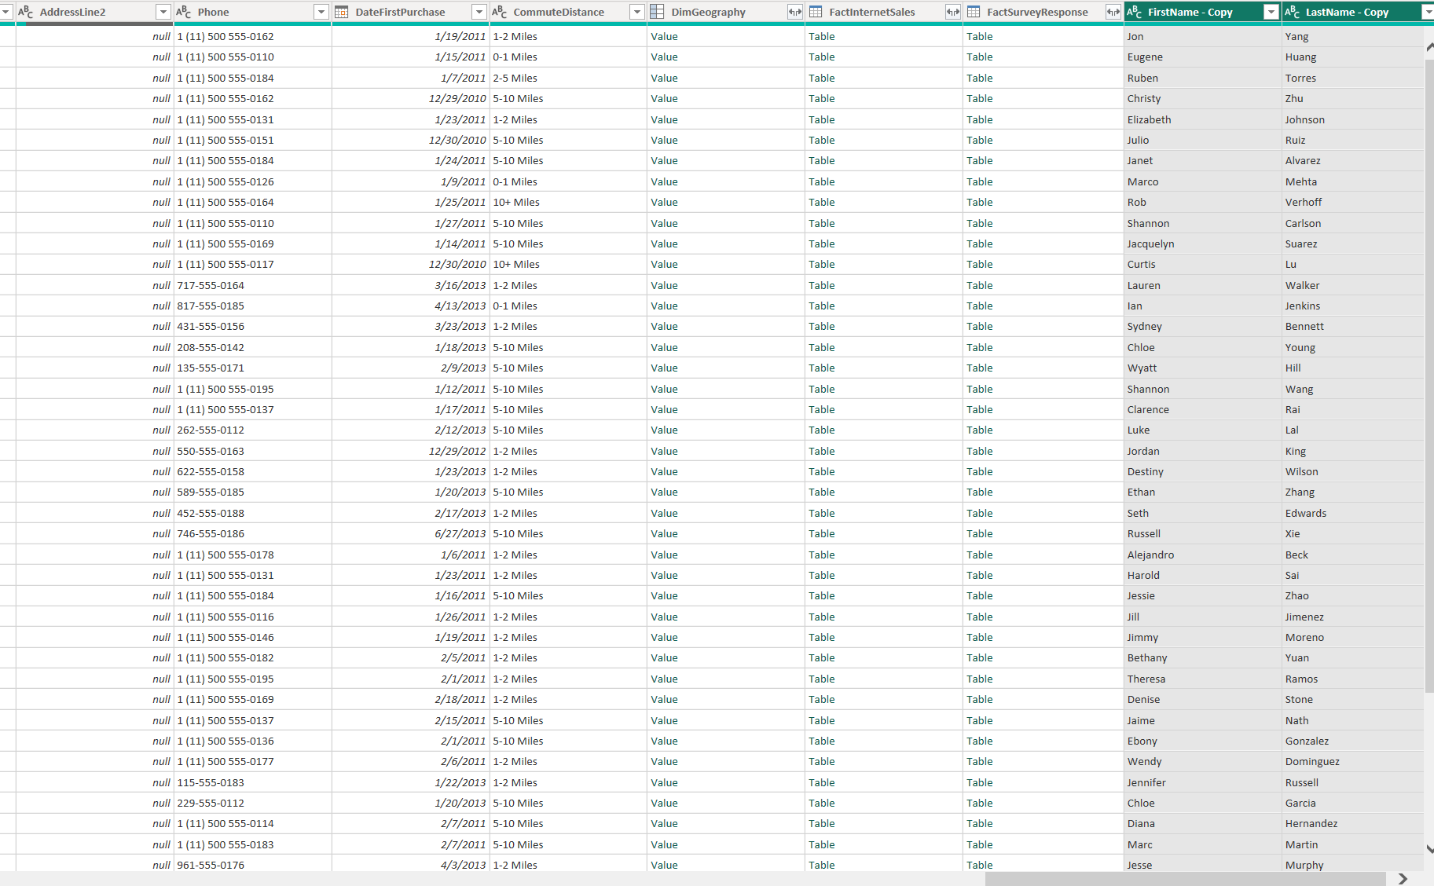
Duplicated columns were merged with space as a separator for the new ‘Full Name’ column
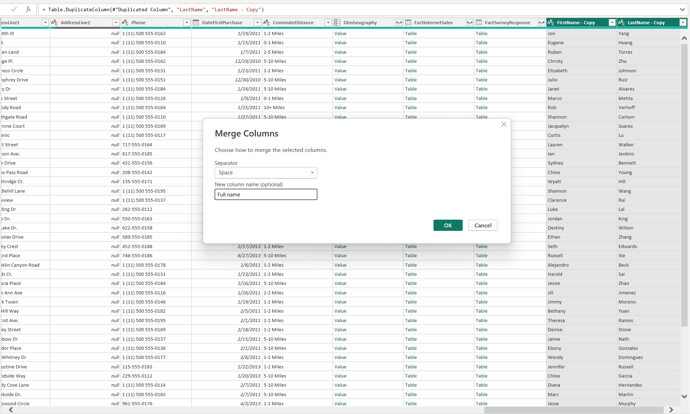
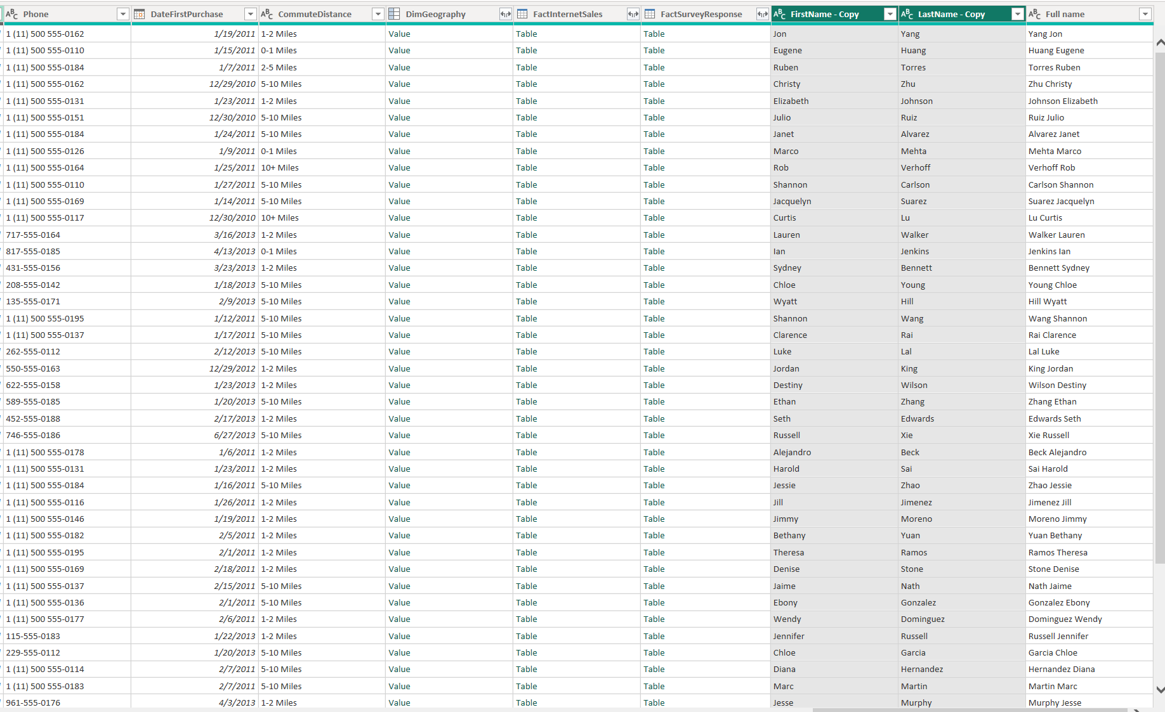
Column type in ‘DiscountPct’ column in ‘DimPromotion’ table was changed to Percentage.
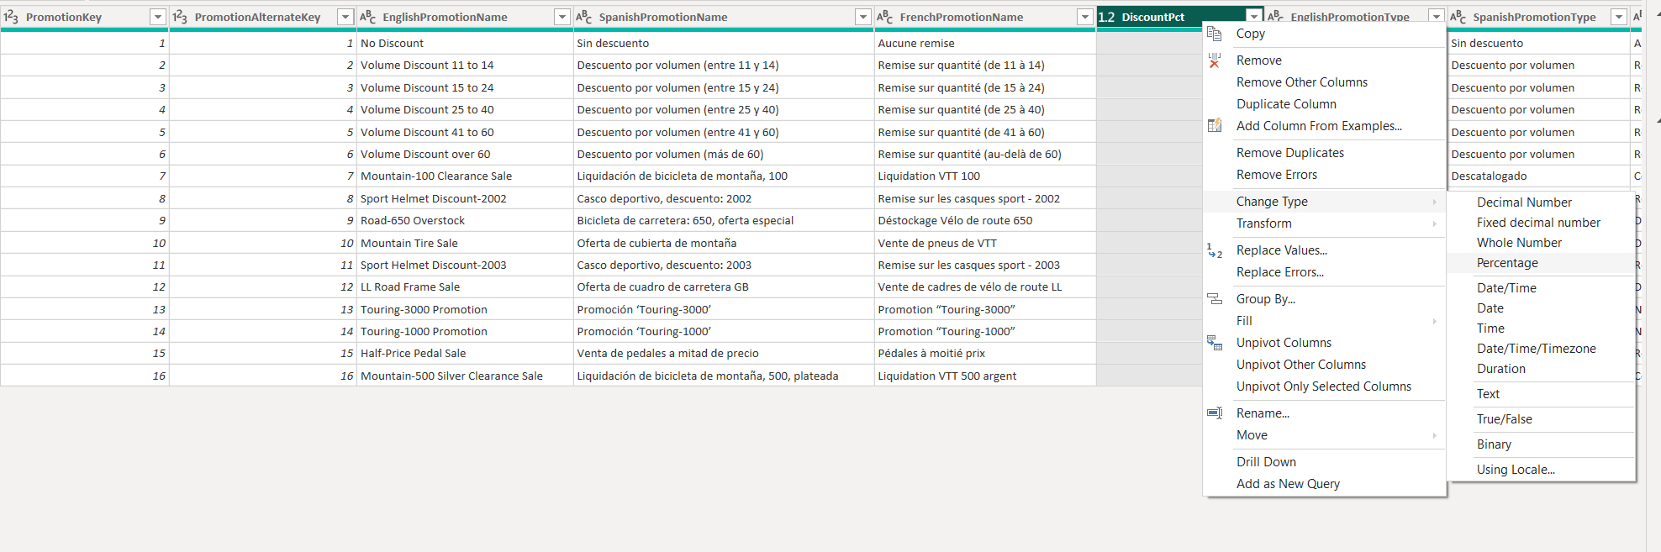
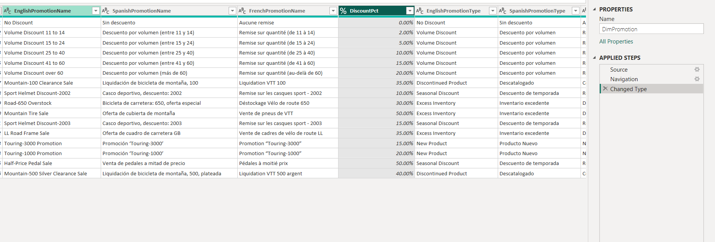
The length of Promo campaign was calculated using option for Date Subtraction:
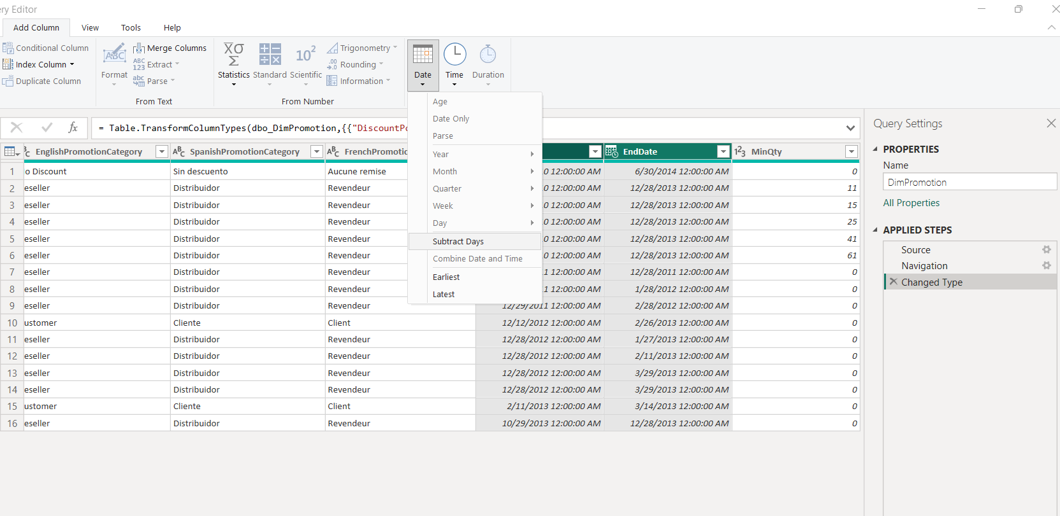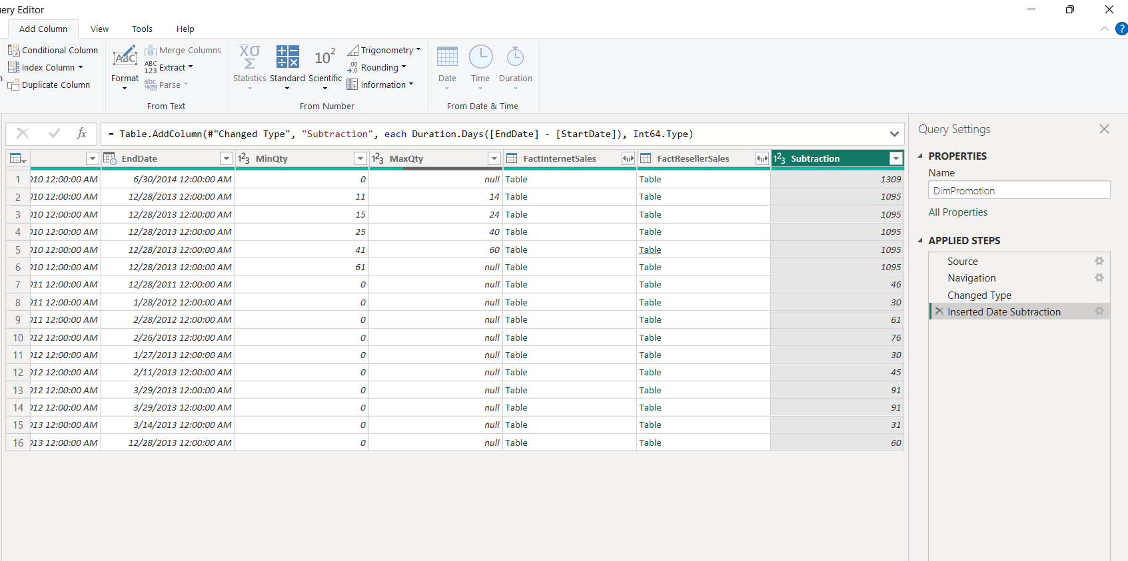

4.3 ADDING NEW TABLES
‘DimProductSubcategory’ and ‘DimProductCategory’ tables from AdventureWorks were load additionally :
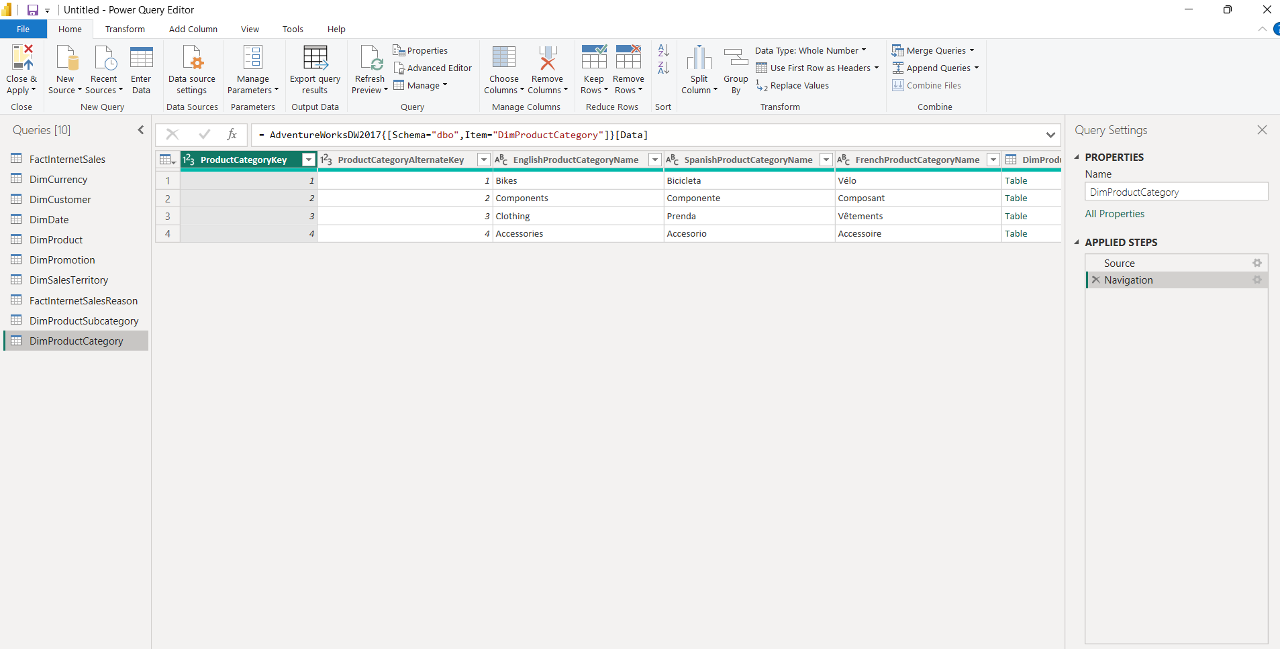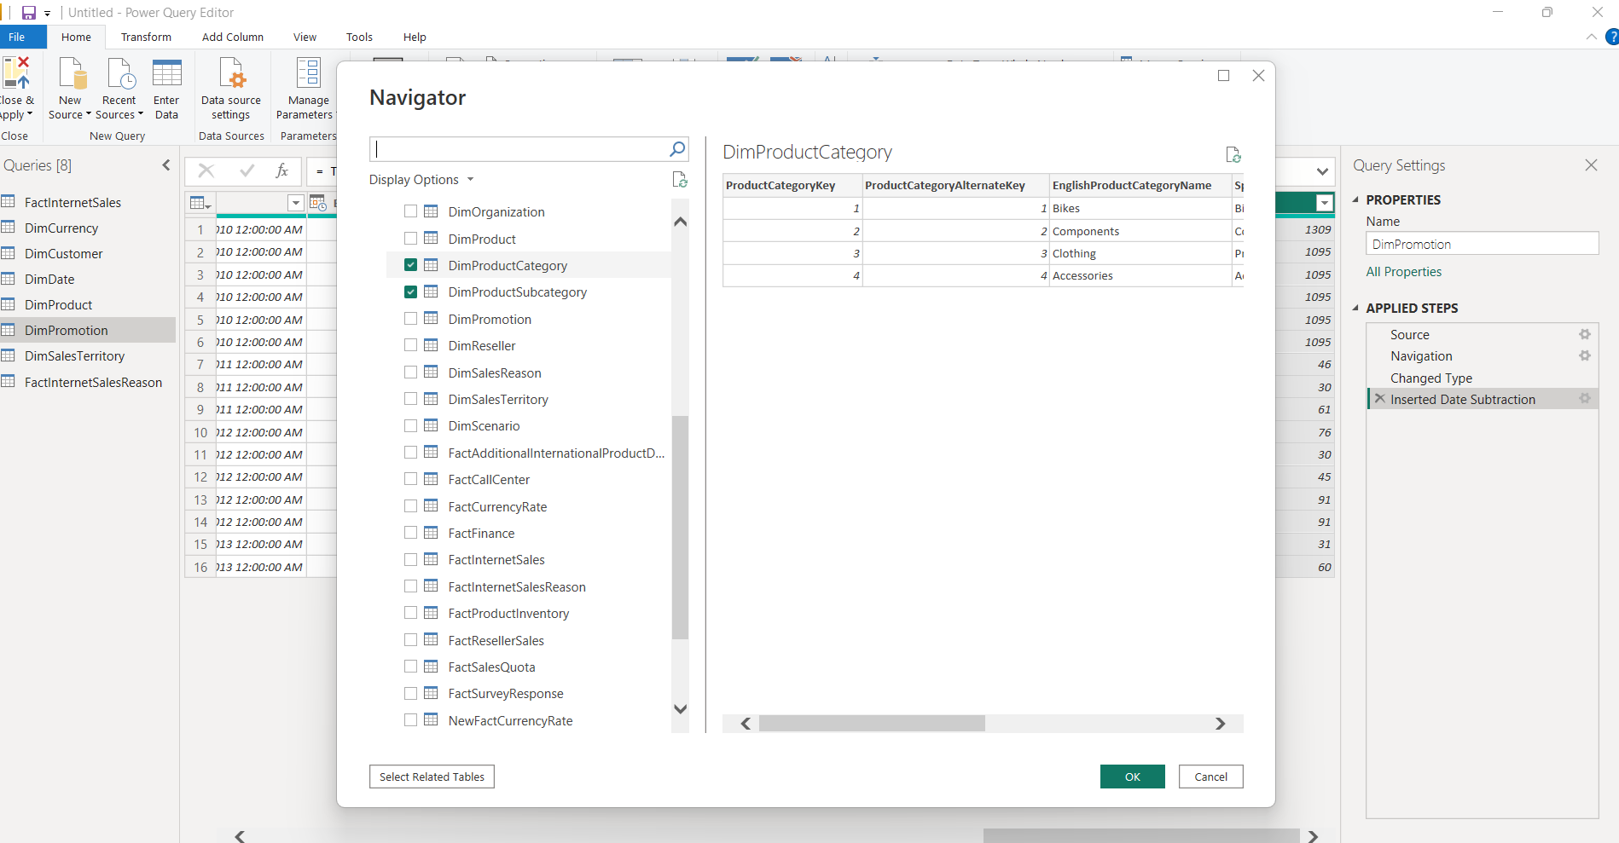
4.4 DATA PROFILING
Options Column Quality, Column distribution and Column profile from View tab was selected:
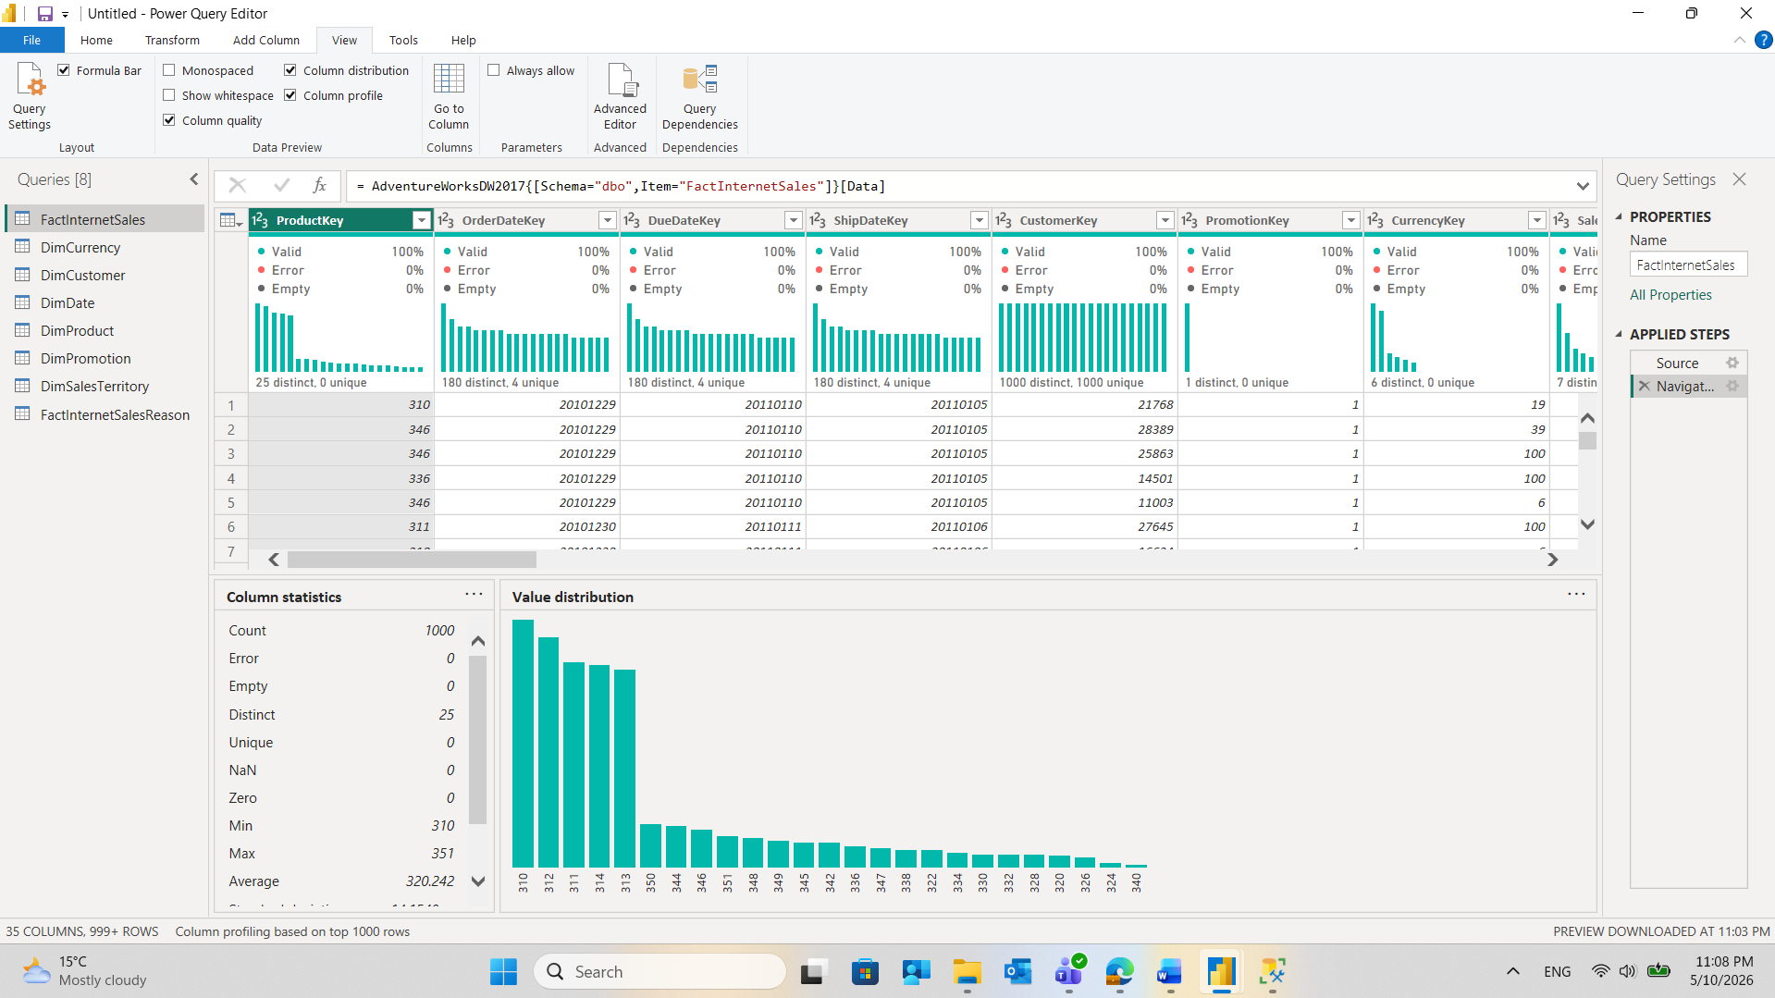
Data Profiling in Power BI is a set of tools that allows to analyse the quality and structure of data before loading it into the report model. It helps identify potential data quality issues early in the transformation process, so they can be resolved in Power Query rather than discovered later in visualisations.
The three options used serve different purposes.
Column Quality shows the percentage of valid, error, and empty values for each column. In the screenshot, Column Quality shows that all visible columns in the FactInternetSales table have 100% valid, 0% error, and 0% empty values, meaning the fact table contains no missing or corrupted data.
Column Distribution displays a histogram of value frequencies, showing the count of distinct and unique values. For example, CustomerKey has 1000 distinct, 1000 unique values in the sampled rows, meaning every customer appears only once in the preview — no duplicates. PromotionKey shows 1 distinct, 0 unique, which means all 1000 sampled rows share the same promotion value, suggesting most sales used the same promotion.
Column Profile provides detailed statistics for the selected column, including min, max, average, count, and a value distribution chart — useful for numeric columns to detect outliers or unexpected ranges. Column Profile is applied to the ProductKey column. The Column Statistics panel shows:
- Count: 1000 rows analysed
- Distinct: 25 — only 25 different products appear in the sample
- Unique: 0 — none of them appears exactly once, meaning every product repeats across multiple sales rows, which is expected behaviour for a fact table
- Min: 310, Max: 351, Average: 320.242 — the product keys are clustered in a narrow numeric range

4.5 Pivot Column
A new column named 'Order Year' was created by extracting the year from the 'OrderDate' column using the Custom Column feature and the following M language formula: 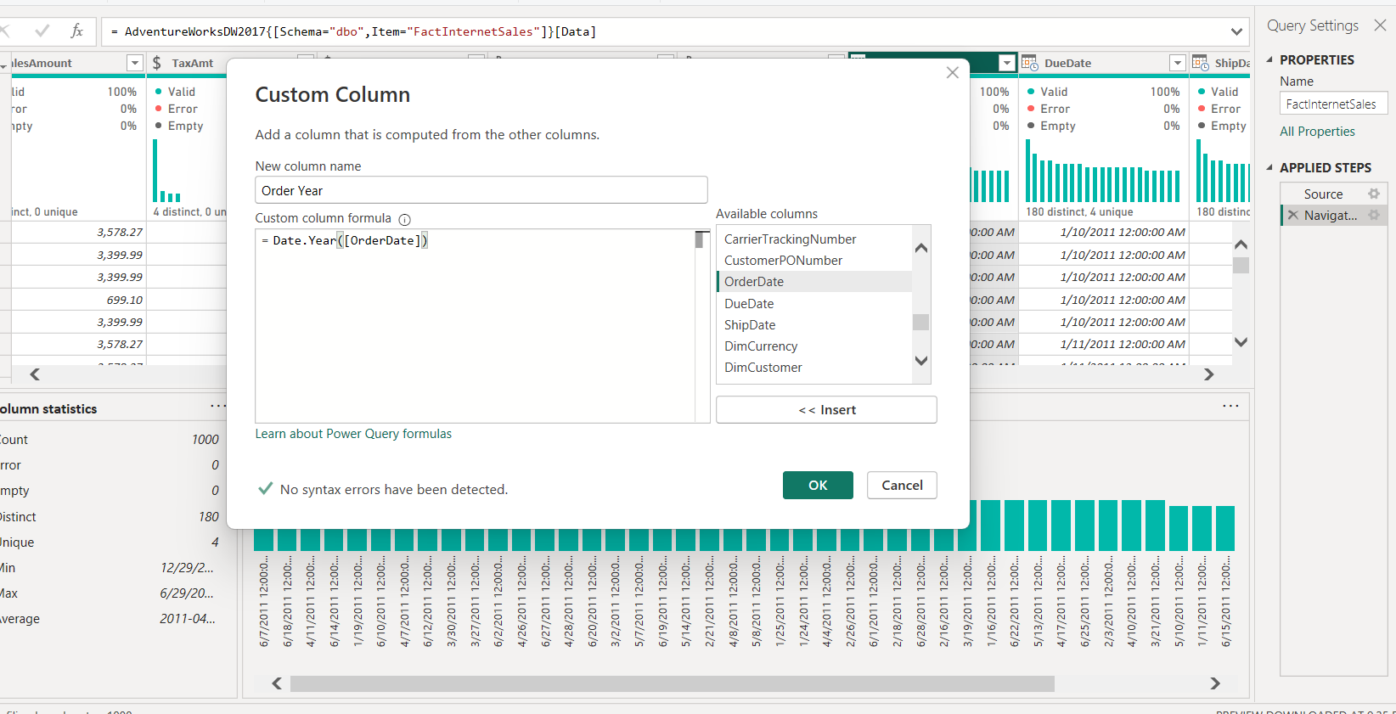
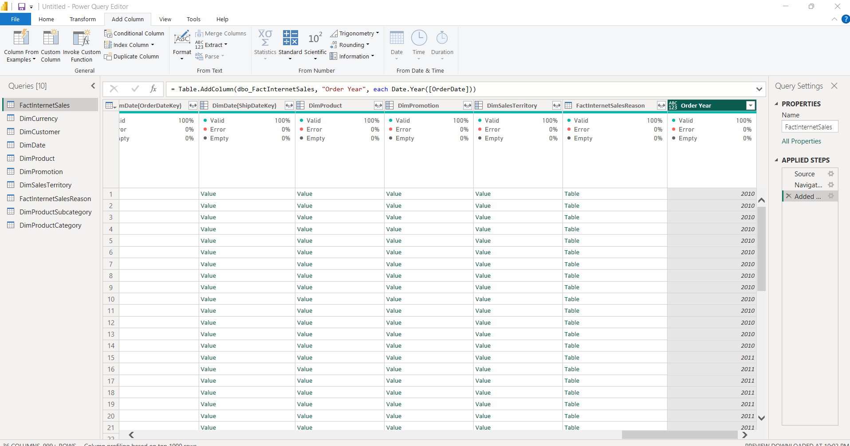
A new table titled 'SalesByYearsNPrice' was generated by using the Reference option from the existing 'FactInternetSales' table
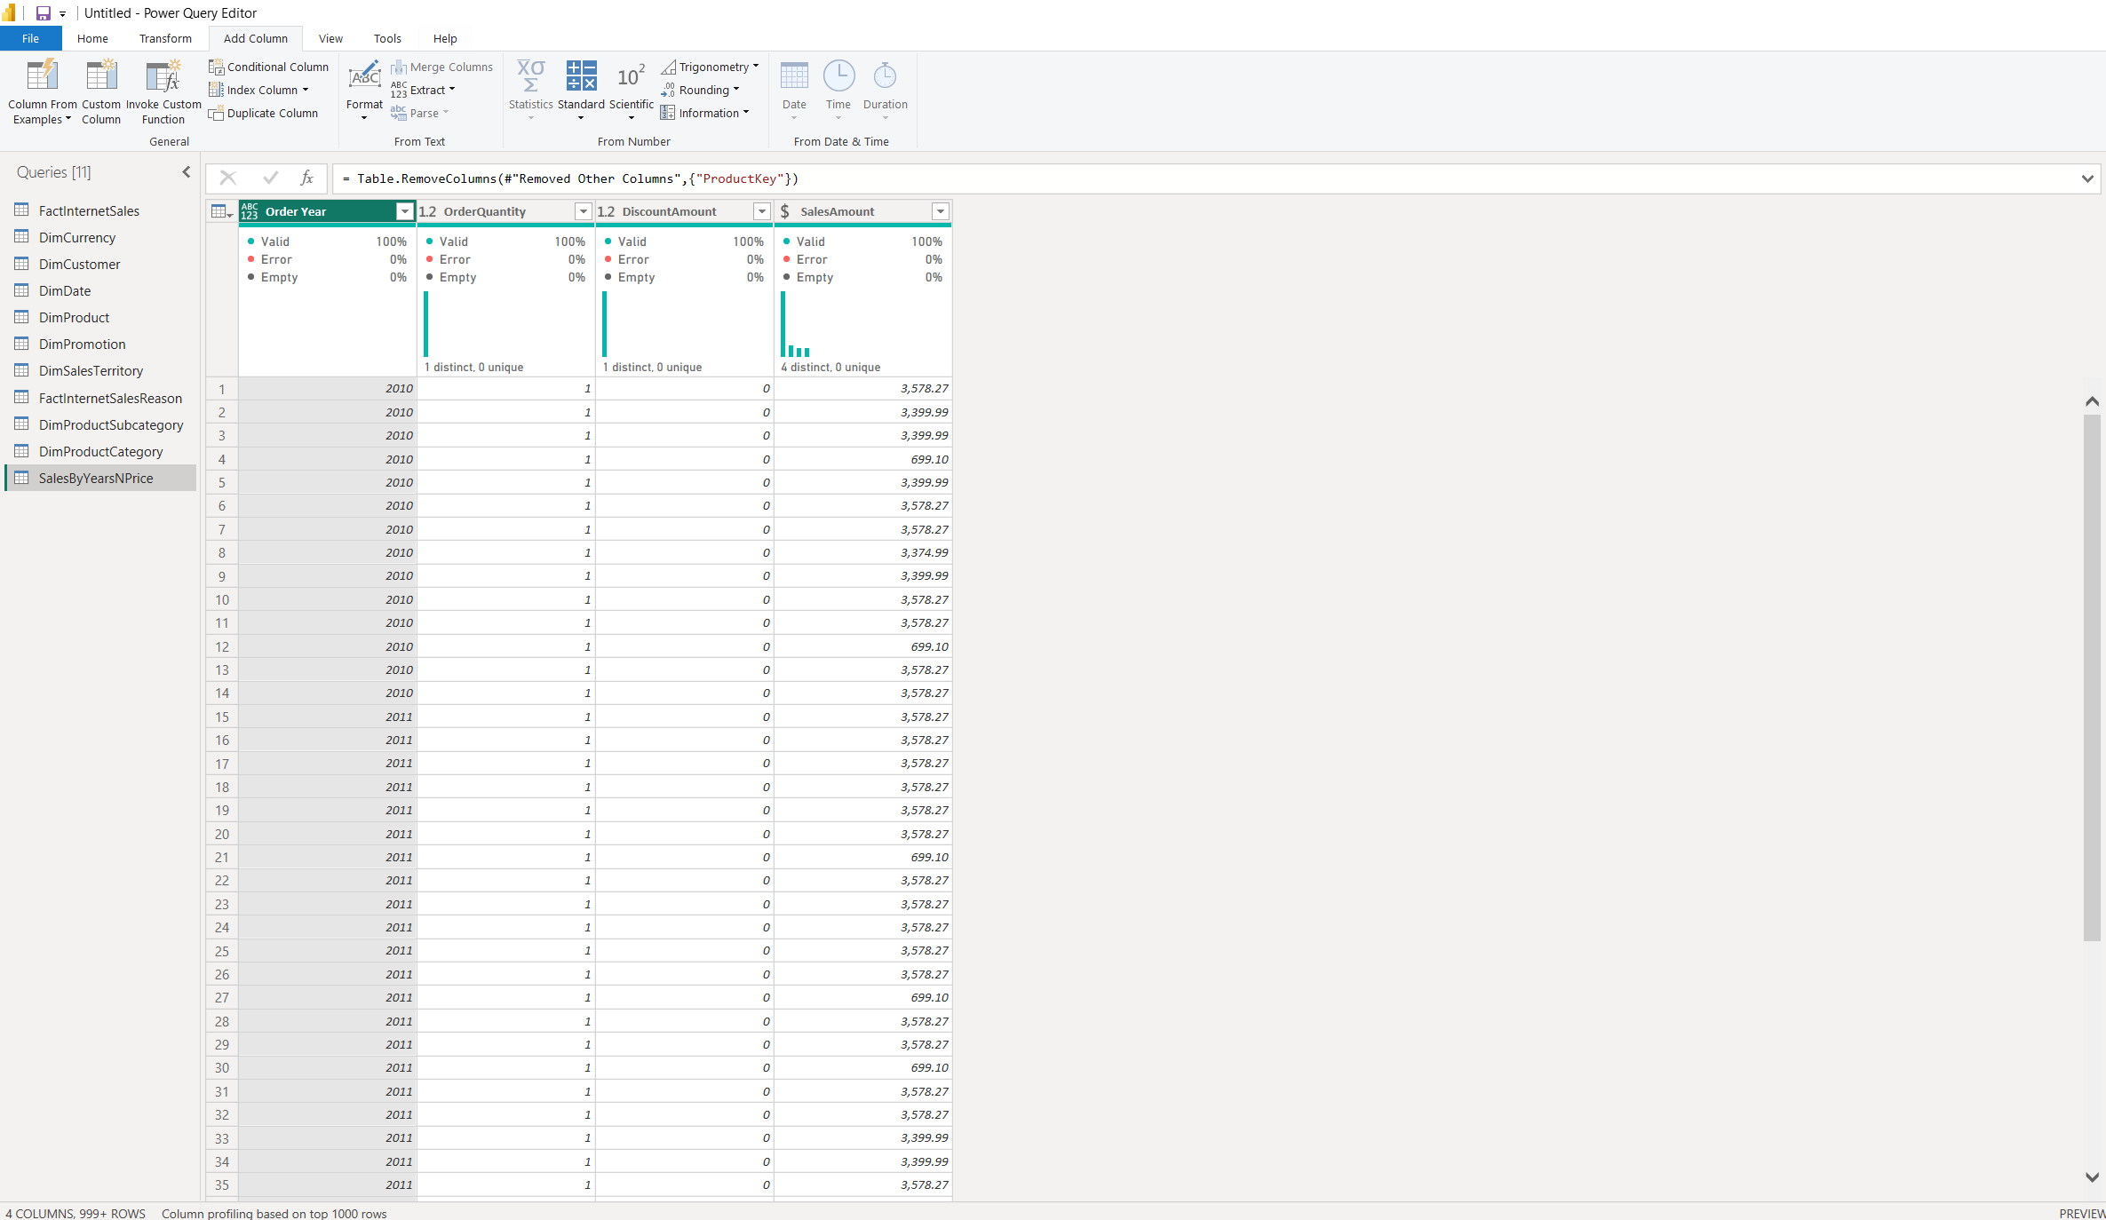
The 'Order Year' column was transformed using the Pivot Column feature with 'SalesAmount' as the values. This effectively converted yearly rows into individual columns, aggregating the total sales figures for year-over-year analysis.
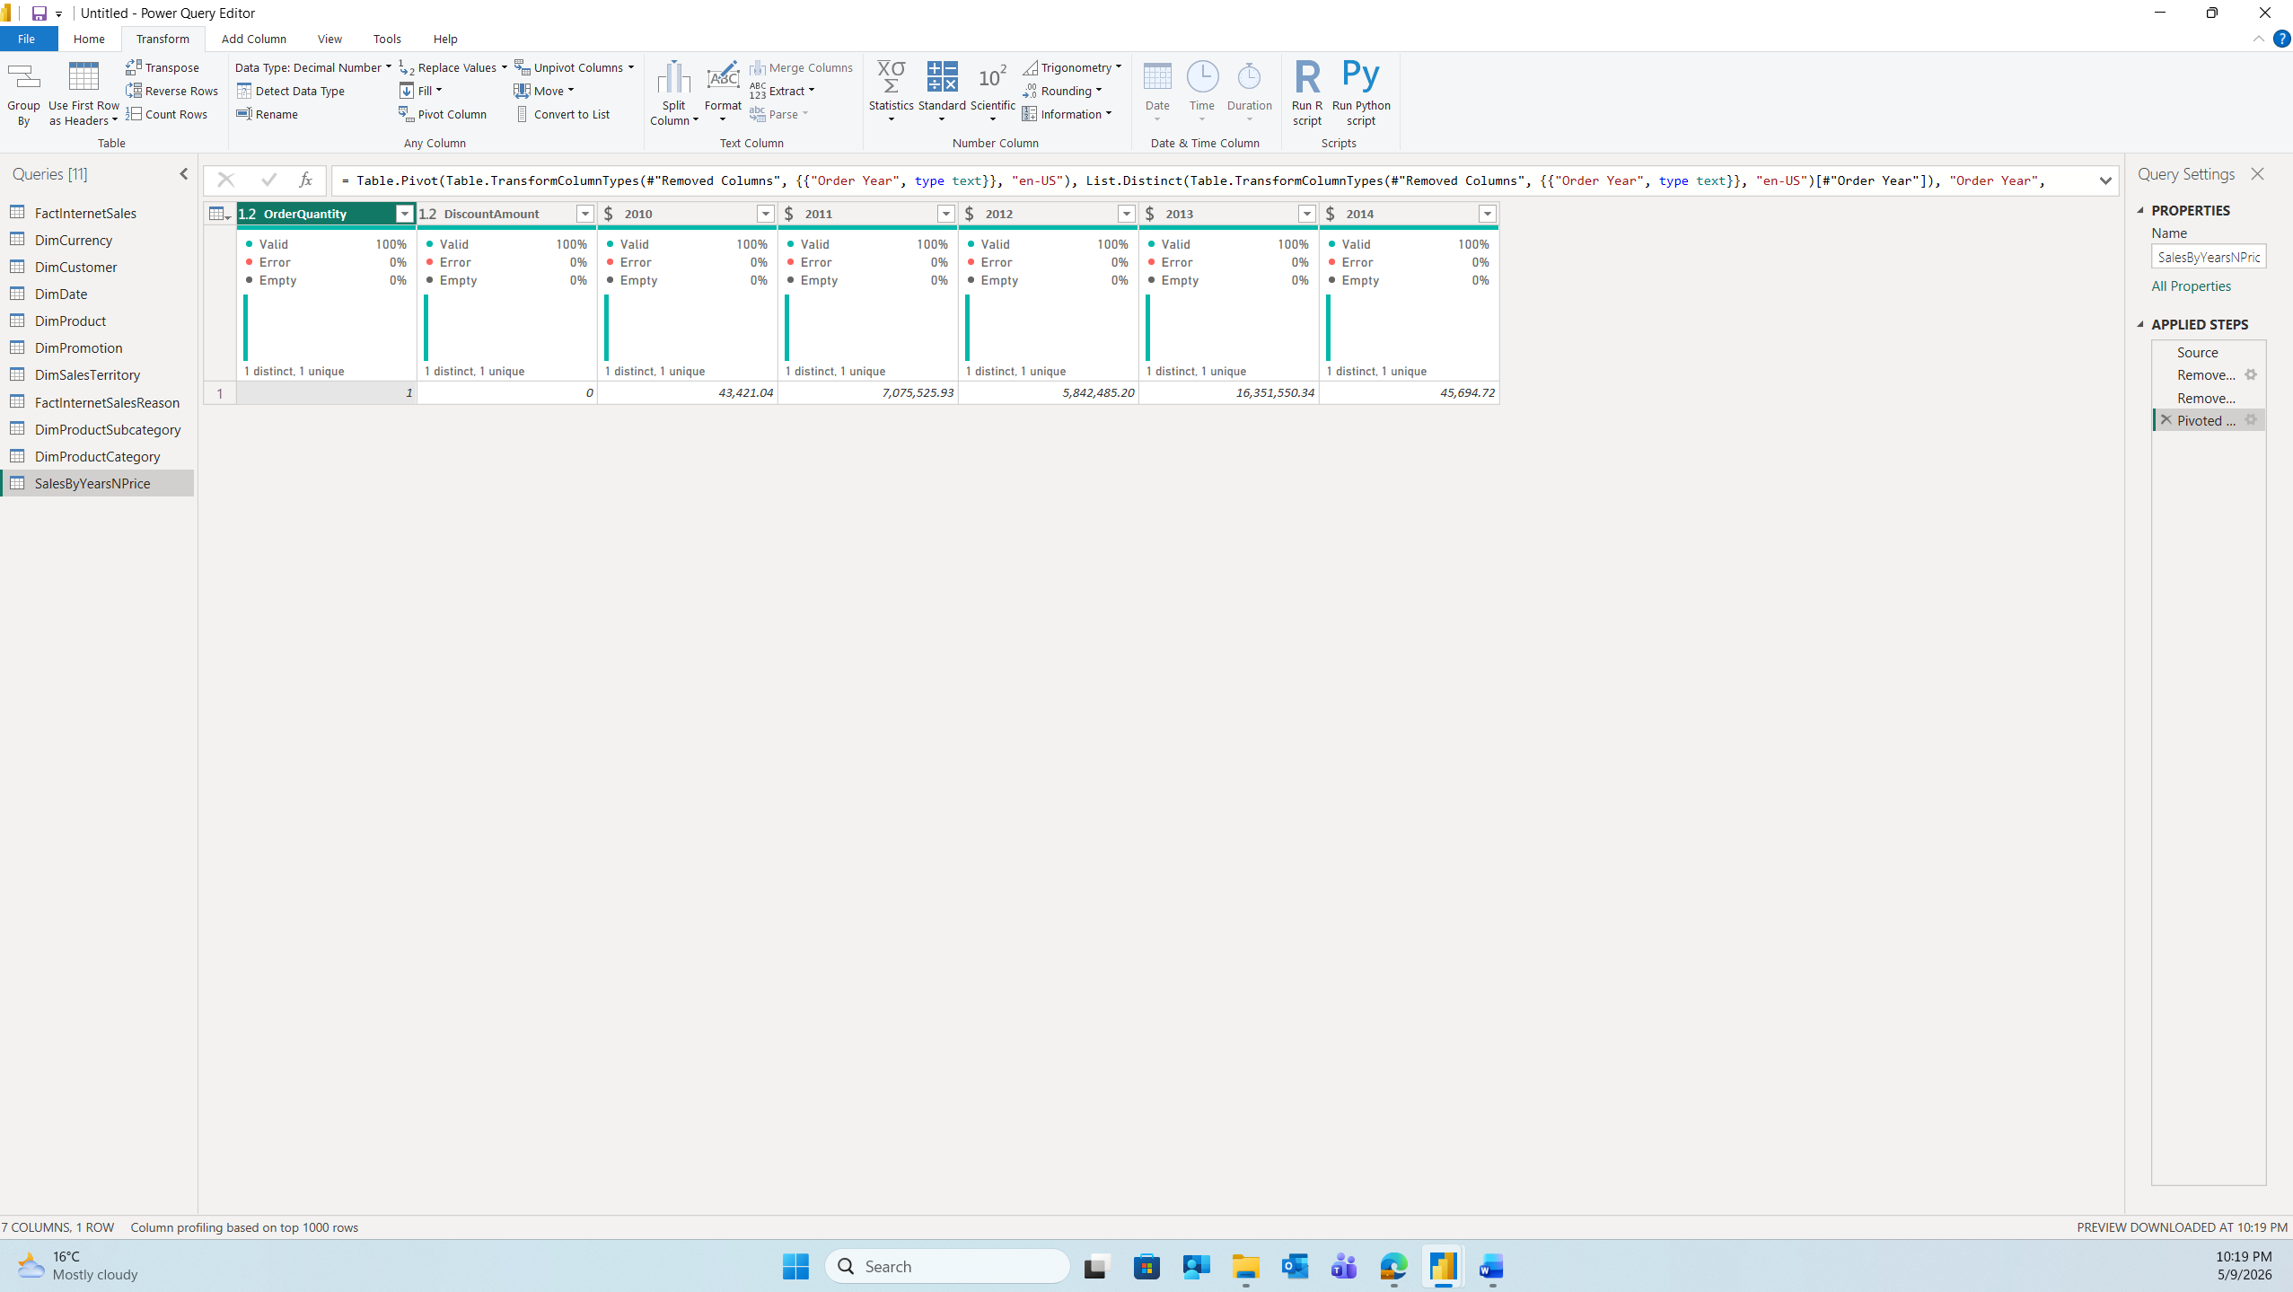
4.6 Table joining
A new table titled SalesByCountry’ was generated by using the Reference option from the existing 'FactInternetSales' table
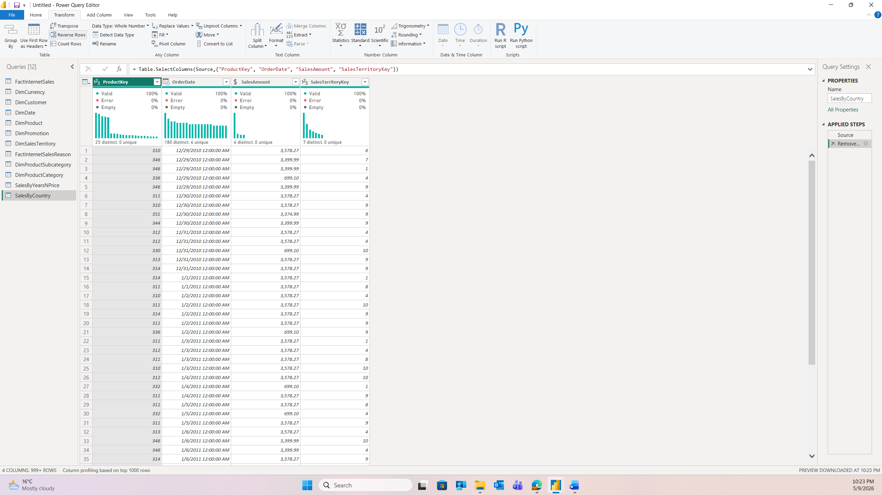
Tables ‘SalesByCountry’ and ‘DimSalesTerritory’ were joined on SalesTerritoryKey using left outer join:
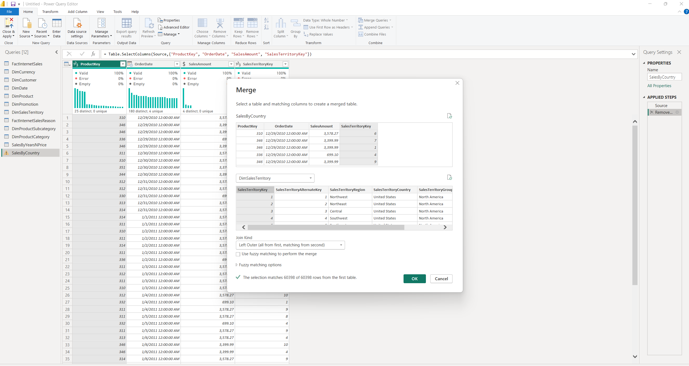
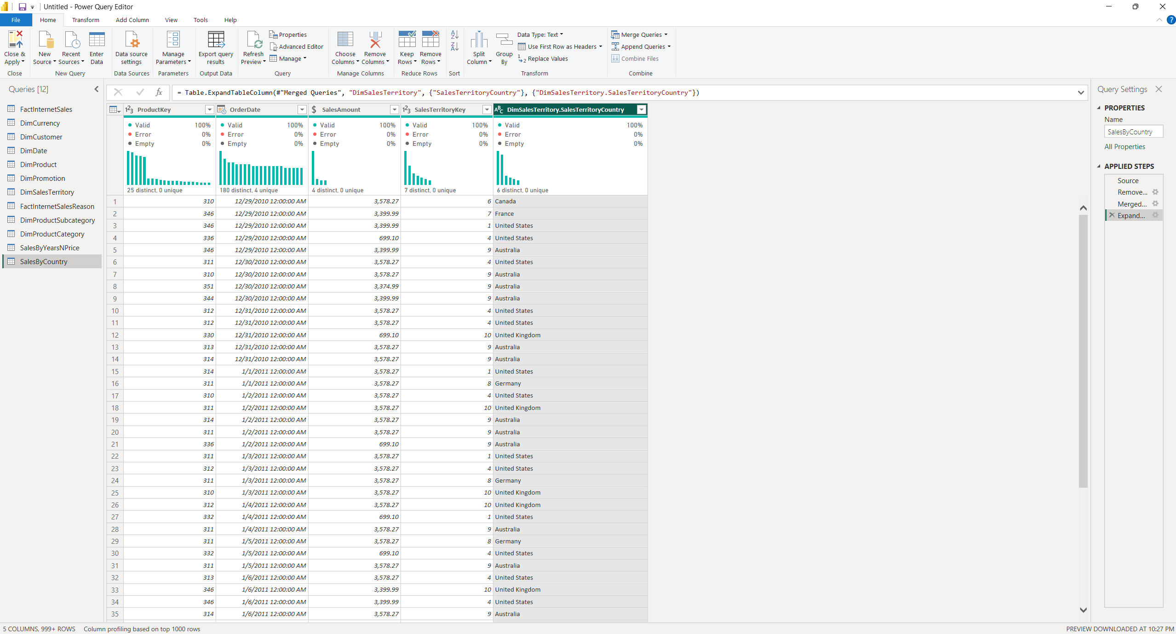
To join DimProductCategory[EnglishProductCategory] columns, firstly tables DimProduct and FactInternetSales was joined on ProductKey. The column DimProductSumcategory was expanded in FactInternetSales:
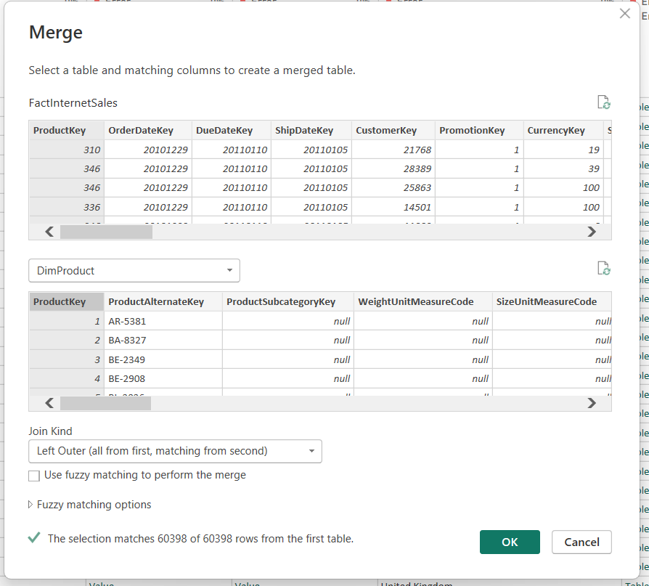
After the tables FactInternetSales and DimProductCategory was joined on ProductSubcategoryKey:
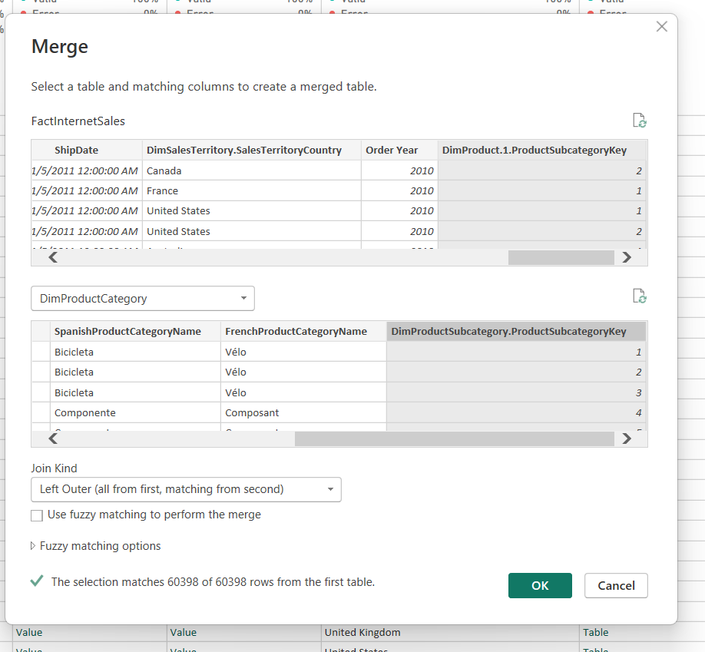
The result:
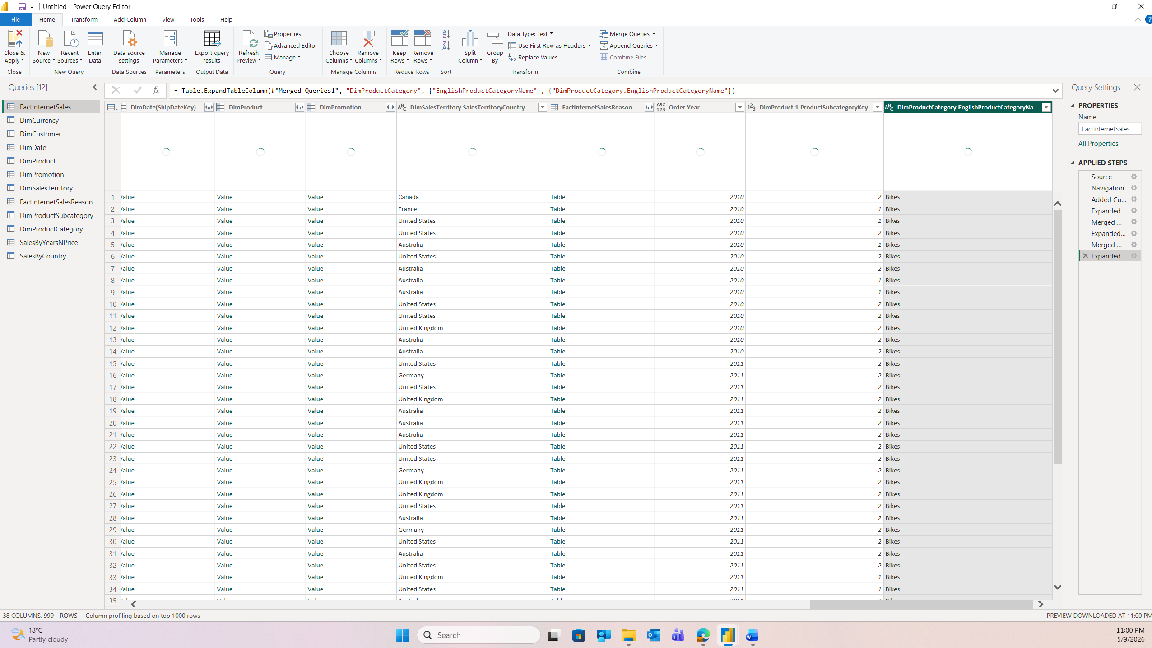
4.7. Grouping Data
The dataset was consolidated by applying the Group By (Advanced) feature, using 'Order Year', 'SalesTerritoryCountry', and 'EnglishProductCategoryName' as the primary grouping dimensions. A new aggregate column named 'Sales' was created to calculate the total 'SalesAmount' for each unique combination of year, country, and category. The resulting table was sorted by 'Order Year'.
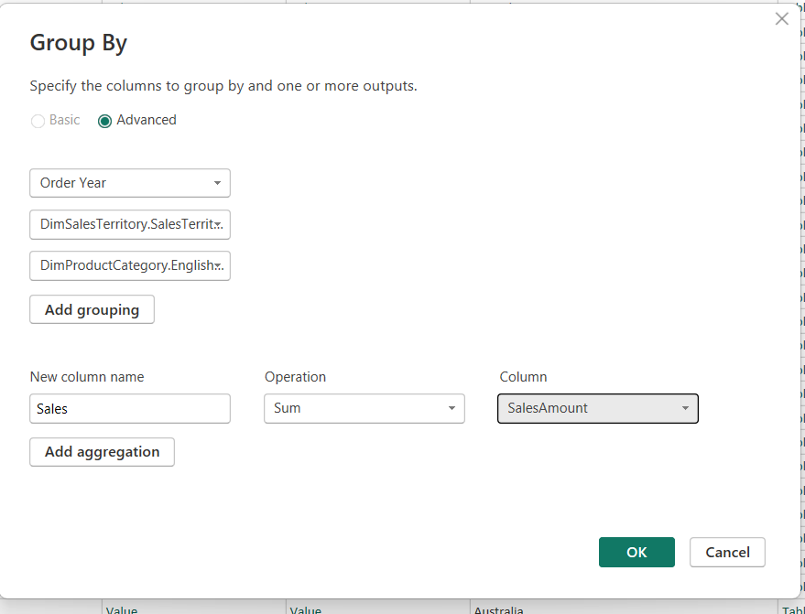
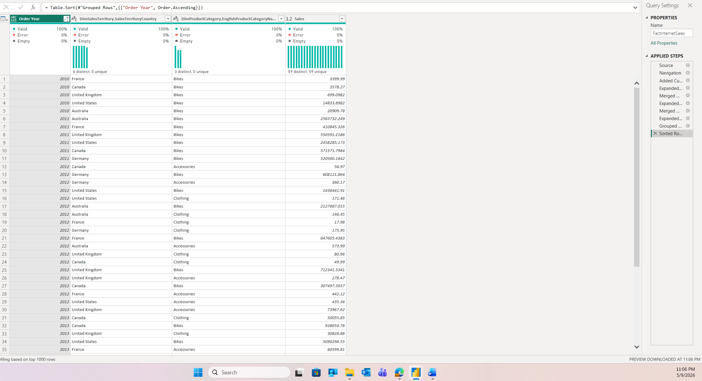
4.8 IMPORT VS DIRECT QUERY
Comparison of Import and DirectQuery Modes:
Data Storage: In Import mode, data is extracted from the source and stored within the .pbix file, whereas in DirectQuery, data remains in the source SQL Server and Power BI only stores the metadata.
Data Refresh: Import requires a manual or scheduled refresh to update the dataset, while DirectQuery provides real-time data access as queries are sent to the database with every interaction.
Interface Availability: The navigator tab (is fully accessible in Import mode), but is hidden in DirectQuery since the data is not held locally.
Performance: Import mode offers the fastest performance, while DirectQuery speed is dependent on the performance of the underlying data source.
File Size: In Import mode, the .pbix file grows in size because it holds a compressed copy of all the data. In DirectQuery, the file remains small since only metadata and query definitions are stored.
Import mode:
DirectQuery mode:
DAX and Power Query Support: Import mode supports the full range of Power Query transformations and DAX functions. DirectQuery has limitations — not all Power Query steps and DAX functions are supported, because transformations must be translatable into SQL queries that run on the source database. Table view is not accessible in DirectQuery:
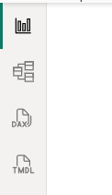
Import is the better choice when the dataset is not too large, when near-real-time data is not required, and when maximum report performance and full DAX support are needed. DirectQuery is preferable when the dataset is very large (too big to import), when data must always reflect the latest state of the source database, or when data governance policies prevent copying data out of the source system.
4.10. WORKING WITH POWER BI MODEL
Not needed relationships were removed between FactInternetSales table and DimDate and the OrderDate connection was made active.
